Stiv’s Guide to SF South Bay Ham Radio

(A resource for new and old Ham Radio Operators)

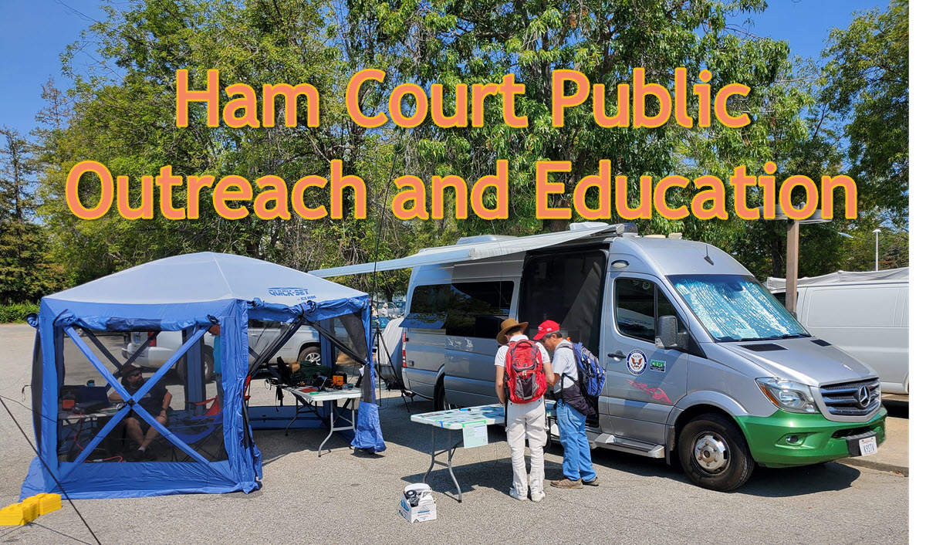
This Guide was written to accompany a folder full of resources labelled MasterHam. I plan to keep handy in event of an emergency, updating as I find new stuff. It contains a collection of Manuals, Software Installers, Reference materials, cheat sheets, etc), stored on a USB key. It takes about 15 minutes to copy to a new key, but only a short time to update and older key to the latest version. Links to the software are provided in this document, actual installers are on the key.
Update on the MasterHam key:
Thanks to Justin, AI6YM you can now access and download whatever files you like from
Index of / (ai6ym.radio)
You can also grab everything from the site using anonymous FTP!

Contents
Introduction 6
New Hams Start Here 7
Very Basic Band Plan 7
Repeaters 7
Limitations of Technician License 8
Some other works in process… 8
MasterHam: 8
Chirp: 8
Ham Radio & You!: 9
Clubs and Organizations In Silicon Valley 9
Hobby Clubs 9
The 50MHz and Up Group of Northern California 9
Foothills Amateur Radio Society 10
Northern California DX Club 10
Northern California Contest Club 10
Palo Alto Amateur Radio Association 10
RDF-SF Fox Hunting 11
San Mateo (Amateur) Radio Club – SMRC 11
Santa Clara County Amateur Radio Association 12
South Bay Amateur Radio Association 12
West Valley Amateur Radio Association 12
Service Organizations 13
Santa Clara County 13
City Groups 13
Infrastructure Organizations 13
ASVARO 14
Silicon Valley Emergency Communications System 14
Southern Peninsula Emergency Communications System 14
Testing Groups 15
BAEARS 15
Sunnyvale VEC 15
Santa Clara County ARES/RACES 16
Websites 16
ARRL 16
APRS.FI 16
Contest Calendar 16
eQSL.cc 16
Logbook of the World (LotW) 17
Introduction to Packet Radio 17
Parks on the Air (POTA) 17
QRZ.COM 17
QRZCQ 18
rdf-sf (Fox Hunting in SF Bay) 18
Santa Clara County ARES/RACES 18
Summits on the Air (SOTA) 19
Software 19
ADIFMerge 20
Amateur Contact Log (See N3FJP Loggers for more) (paid, 45 day demo limited contacts) 20
APRSISCE/32 20
Amateur Contact Log 21
Chirp 21
Direwolf 21
DMapper 21
Echolink 21
EQSL Downloader 22
FDLog 22
Five by Five (Paid) License Prep 23
FLDIGI 23
G4FON Morse Trainer 23
Gridtracker 24
Ham Radio Deluxe 24
HamCall 25
HamClock 25
HAMRS 25
JTSync 26
Kantronics 26
Logbook of the World 26
MeetUp 27
Meinberg NTP 27
MicroLog Logger 27
MSHV 27
NetTime 28
N1MM Logger 28
N3FJP Loggers (paid, 45 day demo limited contacts) 29
OmniRig (Paid) 29
Outpost SCC 30
PuTTY 30
RigResident 31
SkookumLogger (Macintosh) 31
SecureCRT and SecureFx (Paid) 31
TR4W Logger 32
VARA (Paid) 32
Visual Studio Code 32
WinLink 33
WriteLog (Paid $30, registration required for demo) 33
WSJT-X 33
WSJT-X Improved 34
WSJT-Z 34
Yaesu 35
Where to buy gear 35
Amazon 35
DX Engineering 35
Gigaparts 35
Ham Crazy 35
Ham Radio Outlet 35
Powerwerx 36
R&L Electronics 36
Cell Phone Applications 36
Android 36
Repeater Book 36
Grid Square ($3.99) 37
EchoLink 37
HAMRS Logger 37
Ham Clock 37
IPhone 38
Windows Phone 38
NETS 38
Talk Nets 38
9 AM Talk Net (M-F 9am ) 38
FARS Weekly Net (Thursdays, 8PM) 39
PAARA Monday Night Net (Mon 08:30PM) 39
SARA Net (Sun 9PM) 39
SBARA Chat (Mon 7:30pm) 39
SBARA Wednesday Night Roundtable (Wed 8PM) 40
San Mateo Radio Club (T,TH, 7PM) 40
Youth Net (Tuesday, 7PM) 40
EmComm Nets 40
City Nets 40
Group Nets 41
Other Communication Channels 43
Discord 43
Groups.IO 43
SF Bay Area Ham Radio (Stiv’s list) 43
Santa Clara County ARES/RACES 43
Slack 43

Introduction
Hello! My name is Stiv Ostenberg, K9STV. After retiring I made the mistake of raising my hand during a meeting, and ended up on the board of directors for the Southern Peninsula Emergency Communications System. Being on the board, as probably the least experienced ham there, I tried to figure out what my purpose was. I am aware of a generational cliff facing Ham Radio, caused by the aging out of existing hams with not enough new folks coming in to replace them (us). I decided to try to tackle the problem.
I had my license for 10 years, and still was a rookie. I decided that since I had almost given up on Ham Radio, I would try to address what I saw as deficiencies in the Ham community and solve things that had frustrated me.
My first problem was that finding out about opportunities to learn and grow was a pain. There are so many clubs, and not so many events to help new hams learn. I took an idea to the rest of the Board, and they agreed to fund a MeetUp group for Ham Radio in the Bay Area. Not only would this help new hams find groups and things to do, but those events would be visible to the public who might drop in to see what was going on. This document, and the USB key it is contained on are there to make more information available to a new and curious ham, or even to older hams who might have missed something.
My second perceived problem was that while club meetings and events are good, they are not the sort of Hands On training I wanted as a rookie. I hosted several events myself, including Packet in the Park, that simply involved me, and whatever Elmers wanted to join me setting up Packet Radio stations in a park, and inviting people to try a Packet Check-in. We had 6 stations, and about 30 folks drop by to see what we were doing. Getting Elmers out there where Gomers could find them and learn seems an important step. SPECS is covering the cost of the MeetUp, and we are offering any club or Elmer the opportunity to to be a Host and post events, with SPECS covering the cost. I think we also need to start doing more public operating, like a mini field day.
Third issue. Volunteers. I have been bopping around to every club I can get to, and listening to what they are up to. There is a serious manpower shortage in many clubs, with finding volunteers for events (like the flea market or field day) to trying to scrape up a speaker for their meetings. It is my hope that by establishing a interclub communication channel we can send broader requests for help, as well as brainstorm ideas for events and projects that will benefit all of us.
Announce@SF-Bay-Ham-Radio.groups.io | Home

New Hams Start Here

Very Basic Band Plan
If you have just gotten your first ham radio license, you will have a Technician License. Congratulations! I did not understand the plan when I got my license, so giving a simplistic explanation here.
Below is a list of the ham radio frequencies that are available. The areas highlighted in pink are where you are realistically going to be operating, and are known as VHF and UHF. To make life more complex, the bands are often referred to with different titles. For example, the UHF band can be referred to as the 70cm band, or the 420MHz band, OR UHF (ultra high frequency.)

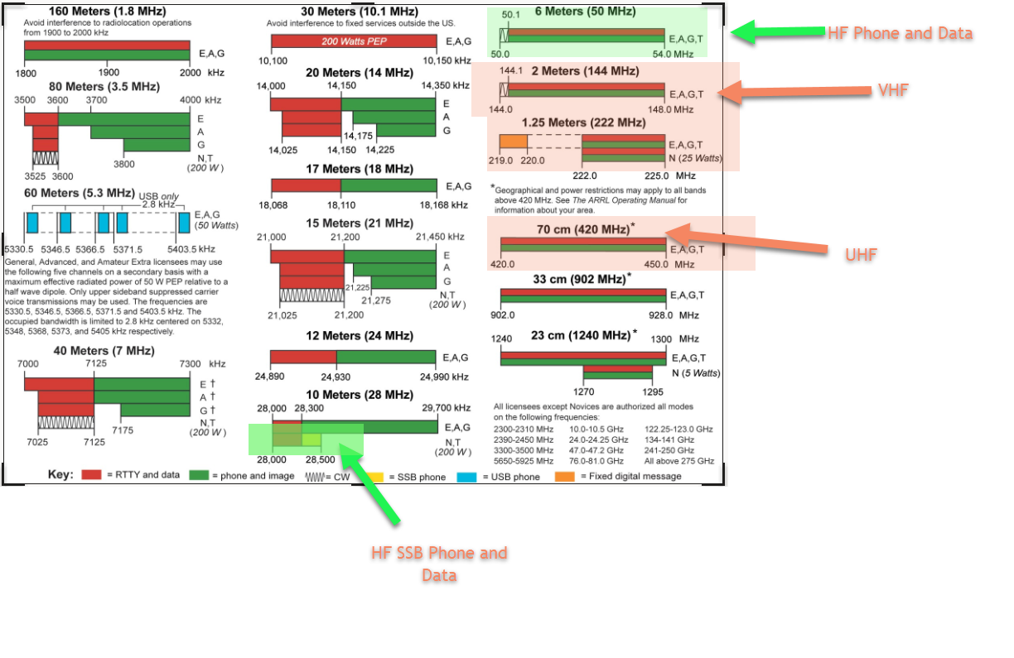
Instead of going into the reasons, which you will learn eventually, a Technician license primarily operates on the VHF and UHF bands. You probably went out and bought a handheld Ham Radio (like the Baofeng) because it is small, inexpensive, and gets you on the air. These handhelds have a limited range, due to the low power signals they generate. Not to worry! While these radios can’t reach far, the Bay Area is littered with repeaters. The repeaters take a low power signal (usually 5 watts) and transmit at a higher frequency (usually 50 watts). The repeaters are also positioned on top of hills or buildings to increase their range.

Repeaters
To use a repeater, you will need to program your radio to send on one frequency, and listen on another. The difference between the frequencies is referred to as the “Offset” is usually automatic, and you need to know whether the offset is positive or negative (this is standard as well, but you may encounter non standard repeaters).
Lets walk you through how this would work. Below are two listings for the same repeater, and it is a pretty active one out of Palo Alto.

1 | N6NFI Repeater  Frequency Offset PL  145.230 -600 kHz 100.0
2 | 145.2300 - 100.0 / 100.0 Palo Alto Santa Clara N6NFI OPEN FM EchoLink

In the examples, the formatting is different, but the information is the same. Since the standard offset is 600kHz it can be stated as in the first example, or implied by the – in the second example. The first example lists the frequency you will program into your radio, the second has extra zeroes at the end, but you can drop those.
The last item is the PL Tone. This is a signal sent to the repeater to tell it to turn on. If the PL Tone is not set, the repeater will ignore you.
So, once you have programmed your radio with this repeater, here is what happens. You are listening to frequency 145.230. You want to talk to somebody, so you push the button on your radio. Your radio adjusts your frequency to 144.170 (a negative offset of 600kHz from145.230) and transmits your message with a PL tone. The repeater listens on 144.170 and hears your transmission. If it picks up the correct PL tone, it then takes your message and transmits it on 144.230. When you release the push to talk button, the repeater stops transmitting, and you tune back to 145.230 to listen. Your friend Herman hears you and grabs his radio. Like you, when he hits the button he transmits on 144.170, but you do not hear him there. The repeater, however, does hear him, and relays his signal back on 144.230 where you are listening. If you are using a handheld radio and broadcasting at 5 watts the repeater will retransmit at 50 watts so your range is effectively increased, and probably from a higher and better antenna!

Limitations of Technician License
While limited HF operation is possible on a technician license, I recommend you get a good VHF/UHF rig to use, and purchase a dedicated HF rig later when you start thinking of upgrading your license. VHF/UHF has limited range, usually enough to reach across a city using repeaters. This makes it ideal for Emergency Communications, both personally and as an ARES/RACES operator (free training!). Getting your General Class license is as easy as the technician license (if you are using a ham cram system) and it really opens up the world for communications, and makes many more activities available to you.

Your first radio!
The number of options you have to choose from can be overwhelming, and what you intend to do should influence your decision. The number of features and the price seem to rise at a constant rate. To make things simple, if you have no idea where you are going to go with Ham Radio, I recommend you start with a Baofeng radio. You can get one on Amazon for about $30 and it will get you on the air. It is not a high quality device, and many folks in Emergency Communications may pooh-pooh it but it works and is affordable.
In Santa Clara County, the workhorse of the EmComm handheld community is the Yaesu FT60R which runs about $160.
If you are sure you intend to use your license, you may want to visit a local club and talk to them about what you would like to do. Be aware that we hams can be opinionated, and folks may be very passionate about different radios. Ask about features that interest you. Some radios have built in GPS and can broadcast their location and home in on other radios using the same feature (GPRS). Some have digital modes giving you more options. If you are juggling these ideas, best to talk to people. (I spent $500 on my first handheld back when I had a good income). Mobile radios (car mount or desktop) have more power and features and can be used with a Packet Modem to do data communications (Packet Radio)

Some other works in process…
MasterHam: Another project, that this file is now part of, is to collect all the programs, manuals, and reference material I can in a single place. I also grab an offline copy of the county website. The total size is currently about 8 gigs. I am going to make copies of the structure to USB keys, and people can bring a USB key, or buy one from me and get all that data. It takes about 15 minutes to copy, but only a short time to update an older key. I am hoping that this key will expand as people suggest more data to shove onto it. This will be useful to both new and old hams, and sneakernet does not use up a clubs internet bandwidth.

Chirp: I am going to be working on building a set of programming files for Chirp. I am thinking one Master file with all the County frequencies starting on channel 30, and each city gets 10 slots for their map. The first 30 channels can be used by the user for whatever they like, including city lineups that may require frequencies be at a specified memory slot. 30-200 or so will be County Channels.
Another file would be for recreational use, with numbers starting after the County Map. It would contain repeaters and Nets, and could be loaded after the county map, or as a standalone memory lineup for people who care not for EmComm. Radio specific settings files might be loaded for radios as needed.

Ham Radio & You!: Another file on this key is a Powerpoint presentation designed to highlight all the activities available once you get your Ham license. I hope to get this out in public to generate interest in becoming a ham, or for existing hams to find new ways to operate. I plan to use this at the EFM, or any other public venue I can get my hands on.

Clubs and Organizations In Silicon Valley
When trying to differentiate between the clubs and organizations in the Silicon Valley, I break them into three categories:
1: Hobby clubs exist to build community among Ham Radio operators. They may have a wide range of interests embracing many aspects of Ham Radio, or they may be a specialized club dedicated to one particular aspect of Ham Radio.
2: Service Organizations exist to provide training and practice for Ham Operators so they are prepared to respond in an Emergency.
3: Infrastructure organizations are groups of hams dedicated to maintaining local resources to be used in an Emergency. Dues from these clubs fund and support local repeaters and other critical equipment. Weekly “Nets” are conducted to verify the equipment is working, as well as allowing local hams to do regular checks of their own equipment to ensure they are ready.
4; Testing groups are groups authorized to conduct tests for your Ham license. Some groups provide a study session with a 90% pass rate, some only administer the test and you must prepare yourself.
Some clubs may actually fall into several of these categories. You are not limited to participating in only a single club! Many (most?) hams are members of various clubs depending on their interests. For example, I am a member of FARS, but I also maintain a membership with SPECS to support the local repeater. I attend meetings of the other clubs, even ones I am not a member of. Hams are friendly folks! The more you get around the more friends you will make.

Hobby Clubs

The 50MHz and Up Group of Northern California
The 50 MHz and Up Group is an educational and public service amateur radio organization centered in the San Francisco South Bay area. The group is interested in developing and utilizing communications on frequencies from 50MHz up through light-waves. The group is open to any related topics that might be of interest to members, such as: technology, design, construction, operation, public service, contesting and antennas.
50MHz and Up

Amateur Radio Club of Alameda
ARCA is an amateur radio club located in Alameda, California affiliated with the American Radio Relay League (ARRL), and serving the East Bay. Amateur Radio encompasses a wide variety of activities from emergency communications to radio contests and outdoor events, and ARCA is engaged in a wide variety of them.

ARCA is very active in emergency communications in association with Alameda CERT teams, the Red Cross and the Alameda Fire Department. The club holds a weekly communications net each Thursday evening to develop and practice skills in emergency communications, an important aspect of disaster preparedness.
ARCA HAM

Coastside ARC (Pacifica)
The Coastside Amateur Radio Club (CARC) is affiliated with the ARRL and normally meets on the second Wednesday of each month at 1930 hours in the Linda Mar Fire Station Community Room on Linda Mar Boulevard in Pacifica. Please check the Coming Events page for any exceptions. Visitors are welcome.

The CARC has been organized since 1959, serving Bay Area amateurs and providing emergency communication services to the City of Pacifica. Membership dues are $20.00 per year for the administration of the Club and publication of the Communicator.

The CARC supports two repeaters and a Packet digipeater on the North Peak of Montara Mountain altitude 1900 feet located on the border of Pacifica and Montara:
Coastside Amateur Radio Club (coastsidearc.org)

Foothills Amateur Radio Society
FARS is an amateur radio organization for the southern San Francisco Peninsula area in California serving residents of Los Altos, Palo Alto, Mountain View, and other nearby communities. Our regular monthly meetings are held on the fourth Friday of the month at Covington School in Los Altos.
FARS - Foothills Amateur Radio Society

Half Moon Bay Amateur Radio Club
The Half Moon Bay Amateur Radio Club (HMBARC) is an association of amateur radio operators and those interested in radio communication as a hobby and for community service in the San Mateo County Coastside communities of Half Moon Bay, Princeton, El Granada, Miramar, Moss Beach, and Montara. We are an affiliated club of the American Radio Relay League (ARRL).
In support of the Coastside communities, we partner with the American Red Cross, Coastside Fire Protection District, and Coastside CERT through the Amateur Radio Emergency Service (ARES®),an ARRL field organization.
HMBARC

Hayward Radio Club Inc (Hayward)
The Hayward Radio Club was formed in the early 1950's.
Web site of: K6EAG The Hayward Radio Club (qsl.net)

Los Altos Hills Amateur Radio Club
We are just getting organized; this page is to describe what we want to accomplish, but feel free to suggest improvements! (As of September 2024)
The town of Los Altos Hills and the Los Altos Hills County Fire District have a robust program to respond to disasters. But the old home for amateur radio (the Emergency Communications Committee - ECC) was retired by the town.
This ham club is meant to be the replacement for the ECC for amateur radio operators.
Our current goals for the club are:
- Be a social club to encourage participation and have fun
- Mentor new hams (and old hams learning new things)
- Find people to experiment with (e.g. LoRa, HaLo)
- Maintain the repeater and ham radio equipment in town
- Train ham radio operators so we are prepared for emergencies
- Conduct drills to test our knowledge
We are just forming the club and working on our procedures and goals. We'd love to have you participate!

Millbrae Amateur Radio Club
Our club members are committed to support communications in the City of Millbrae for events and emergency situations when normal means of contacts are not available.
To provide auxiliary communications as required by the San Mateo County Sheriff’s Office when requested.
To promote learning communications techniques and technological advances in the art of amateur (ham) radio.
Provide a social setting for individuals interested in the radio hobby and a forum to exchange ideas.
Millbrae Amateur Radio Club (millbraearc.org)

Northern California DX Club (Mountain View)
The NCDXC was formed in 1946 and has over 200 members from all over Northern California, with most of the members residing in the 9 Bay Area counties. The NCDXC holds monthly meetings, maintains a repeater high above Silicon Valley, and provides an active on-line CHAT reflector. NCDXC member’s interest in DX is varied. Some members enjoy chasing entities for DXCC, five band DXCC, IOTA, Grid Squares, five band worked all zones while others chase DX on 6 meters and EME.
If you are beginning the chase for DX entities, NCDXC members will be happy to provide help to reach your next DX goal.
Northern California DX Club

Northern California Contest Club
The Northern California Contest Club is a specialized amateur radio club devoted to the pursuit of operating and technical excellence in radio contesting. Our goals are:
- To promote the fun, satisfaction and competitive thrill of radio contesting
- To help our members develop their operating and technical skills to become better contesters
- To win the club competition of major amateur radio contests
As an ARRL affiliated Club, NCCC was founded in August 1970. We have over 300 active members located throughout Northern California and parts of Nevada. NCCC counts as its members many #1 world ranked contest winners. NCCCers are also into DXing, technical design and construction (especially antennas), and public service
NorCal Contest Club Home Page

Oakland Radio Communication Association
Emeryville, CA · Piedmont, CA · Oakland, CA · Alameda, CA · Berkeley, CA
ORCA - Oakland Radio Communication Association (ww6or.com)

Palo Alto Amateur Radio Association
PAARA, “The Friendliest Ham Club Around”, is a general interest club that has members enjoying almost all aspects of amateur radio. With over 200 active members, surely someone in the club has experience in whatever activity you may find interesting. PAARA holds monthly meetings on the 1st Friday of every month, except when holidays fall on that Friday. Our meetings are held at the Cubberley Community Center in Palo Alto. Meetings are open to anyone, licensed or not, members or not. We do, however, invite you to join and learn with the rest of us.
Meetings include information on current ham radio news, upcoming on-air activities, and announcements of local events. Every meeting has a speaker whose topic is generally related to some aspect of amateur radio but maybe more of a general interest topic. A raffle is held at the conclusion of the meeting when lucky winners take away a variety of prizes, most related to our hobby. Every January is our Home Brew night where members bring various projects they’ve been working for show and tell. The December meeting features our “Dream to Reality” raffle where the grand prize is an HF radio!

PAARA - Meetings

RDF-SF Fox Hunting
RDF-SF is not actually a club, but a group of Hams who get together once a month to run a Radio Direction Finding event, also called a Fox hunt. You may join a team to ride along and learn, and later start to gather your own setup and start your own team.
rdf-sf.org

San Bruno Amateur Radio Club
The SBARC is open to all licensed Amateur Radio Operators, and those with an interest in Amateur Radio. Part of our mission is to provide radio communications to the City of San Bruno in a time of need. We operate the radio room at City Hall, and other designated locations. We have monthly meetings, where we discuss Amateur Radio topics and other related items. We participate in training exercises and drills. Occasionally, we have social dinner meetings with other clubs.
We continually strive to expand our knowledge of Radio Science, and promote fellowship among Amateur Radio Operators.

The San Bruno Amateur Radio Club (94066hams.org)

San Francisco Amateur Radio Club
The San Francisco Radio Club (SFRC) was formed in 1909 by a handful of radio enthusiasts with the objective of exchanging messages over the air. In 1916 the president at time, Henry W. Dickow (6HD), founded the club and published the first Yearbook.
Today, 100 years later, the SFRC continues to operate as a not-for-profit Amateur Radio Club servicing the city of San Francisco and the community. Our members’ interests cover the entire spectrum of what Amateur Radio Service has to offer. We are a long standing member of the American Radio Relay League (ARRL) and with our members we participate in, and organize events including Field Day, supporting the San Francisco Marathon.
Join our Slack community, e-mail info@sfarc.org
San Francisco Radio Club - Home (sfarc.org)

San Mateo (Amateur) Radio Club – SMRC
The San Mateo Radio Club has served the Amateur Radio community on the San Francisco peninsula since 1946. The club promotes the exchange of knowledge among members at monthly meetings, serves the local community with emergency communication, and helps newcomers get on the air. Meetings cover a wide range of radio related topics such as DX (long distance communication), digital radio, new technologies, equipment reviews, competitions (contests), emergency protocols, remote region expedition communications (DXpeditions), and much more. The club’s goal is to improve its member’s technical and operating capabilities and to foster fellowship.
Meetings
The San Mateo Radio Club meets the third Friday of the month at 7:15pm on Zoom and at the Congregational Church of San Mateo. Each meeting has a presentation on a topic of interest in amateur radio. There are plenty of opportunities to ask questions and get help with problems.
Membership
Membership is open to anyone with an interest in amateur radio. The annual dues are $25.
To become a member, either through the mail with a physical check, or with credit-card online, the process starts out the same on our web form: http://w6uq.org/dues
Weekly Radio NET
Join us for the San Mateo Radio Club 2-meter Net every Tuesday and Thursday evening at 19:00 PT on the N6ZX repeater:
• Output: 145.370 MHz, Minus offset of 600 KHz
• Tone CTCSS (PL): 107.2 Hz
Our thanks to the Kings Mountain Amateur Radio Club for allowing us to use their repeater for our weekly NET.
More Information
• To receive our monthly email: http://www.w6uq.org
• Main web site: http://www.W6UQ.org
• Twitter: https://twitter.com/cqw6uq
• ARRL listing: http://www.arrl.org/Groups/view/san-mateo-radio-club-inc/type:club
• FCC listing: http://wireless2.fcc.gov/UlsApp/UlsSearch/license.jsp?licKey=814328
Club site
San Mateo Radio Club - W6UQ (google.com)
Club MeetUp
San Mateo (Amateur) Radio Club - SMRC | Meetup

Santa Clara County Amateur Radio Association
SCCARA was formed as a general interest amateur radio club in 1921
and became a non-profit corporation in 1947.
SCCARA is an affiliate of the American Radio Relay League
Welcome to S.C.C.A.R.A. Home Page (qsl.net)

Saratoga Amateur Radio Association
Our Emergency Communications Committee is responsible for coordinating our emergency communications function within the City of Saratoga. The Emergency Coordinator (EC) is appointed by the ARRL Section Emergency Coordinator and the Assistant Emergency Coordinators (AECs) are selected and appointed by the EC.

About Us – Saratoga Amateur Radio Association (k6sa.net)

SC4 Amateur Radio Club
We bring together the communities of La Honda, Loma Mar, Pescadero, San Gregorio, South Skyline, Butano, Middleton Tract, and Skylonda for training in emergency communications and neighborly talk.

SC4ARC.org

Stanford Radio Club
W6YX is a Federally Licensed radio station which operates on the Amateur Radio (aka Ham Radio) bands. We are a group of radio and technology enthusiasts who enjoy learning about radio, building projects, and talking around the world.
Home (stanford.edu)

South Bay Amateur Radio Association (Fremont area)
South Bay Amateur Radio Association (SBARA), was formed in 1976 to cater to the amateur radio communities in the Fremont, Newark and Union City in the East Bay.
The club welcomes people of all ages interested in Amateur Radio and helps them become licensed operators to enjoy the hobby first hand. The club conducts regular monthly meetings, and invites a guest speaker to give a talk and discuss interesting projects. Every year SBARA participates in the ARRL Field Day, inviting everyone to join in the fun. Let us help you discover and enjoy the Radio Sport !

SBARA South Bay Amateur Radio Association, KU6S

Troop 27 and Crew 27 Amateur Radio Club
Venture Crew 27 is part of the Pacific Skyline Council of the Boy Scouts of America. We are sponsored by Congregational Church of Belmont but are a non-denominational crew.
We Are:
One of the Oldest Crews Around: Founded in 1999, we are one of the oldest continually running Venture Crews in the country.

Up For A Challenge: We offer everyone who joins our crew the chance to have fun while learning skills and experiencing personal growth that will last a lifetime. Our objective is that all youth participating in our crew feel they have had a challenging, rewarding and enjoyable experience.

Youth-Led: Mentored by adult advisors, crew members choose and plan for all outings, service projects, social events, and Super Trip.

A BSA Quality Unit: Crew 27 has achieved the BSA Quality Unit status every year since it started.
About Us | Venture Crew 27 (terfry.com)

West Valley Amateur Radio Association (San Jose Area)
WVARA meetings are on the second Wednesday of each month except July, August, and December. Our meetings start at 7:00 pm.
Visitors and guests are welcome to attend the meetings, and pre-meeting gatherings!
We meet at the Santa Clara Valley Chapter of the American Red Cross, at 2731 North 1st Street in San Jose.
Pre-meeting Unofficial Gatherings: For Location and time, please contact Jim K6EI using the email address on his QRZ.com page.
WVARA Monthly Meetings - WVARA HOME

Service Organizations
Ham Radio operators who wish to serve their communities are a strong presence in Santa Clara County. Whether providing critical communications links in a disaster, or supporting local events training and practice are critical. In Santa Clara County, the Santa Clara County ARES/RACES group is the central hub for providing training, and running drills and exercises to keep our skills sharp and ready to use. All hams should register with the County site to avail themselves of the free training, and the excellent reference information on the site.

Santa Clara County ARES/RACES
Santa Clara County ARES/RACES

San Mateo County ARES/RACES
South County ARES (Southern San Mateo County, CA) (k6mpn.org)

City Groups
Beneath the County organization, individual cities have their own groups.
Cupertino Amateur Radio Emergency Service (CARES)
Gilroy - Garlic Valley Amateur Radio Club (GVARC)
Loma Prieta Amateur Radio Club (LPARC)
Los Altos Amateur Radio Emergency Service - LAARES
Los Gatos / Monte Sereno ARES/RACES (LGMS-ARES/RACES)
Milpitas ARES/RACES (MARES)
Mountain View ARES/RACES
NASA/Ames
San Jose RACES
City of Santa Clara ARES
Saratoga Amateur Radio Association (SARA)
Sunnyvale Amateur Radio Emergency Services (SARES)

Infrastructure Organizations
Infrastructure clubs are clubs that exist to maintain critical infrastructure for use in disasters. They maintain and fund local repeaters, and run weekly “Nets” to both test the equipment and give operators a chance to manage and run the Nets so they are prepared in a disaster. The Nets usually consist of announcements of coming events and news, and a role call of the operators present. People checking into the net are able to verify that their equipment is ready to go if disaster strikes.

ASVARO
The Association of Silicon Valley Amateur Radio Organizations is not technically a club, but rather a committee formed by representatives from a number of clubs in the area.
ASVARO organizes the monthly Electronics Flea Market “swap meet” at West Valley College in Saratoga, California. The markets are generally held on the second Sunday of each month March through September. Be sure to check the schedule for the exact dates and latest information. This event benefits a different club each month.
I am trying to recruit Ham Radio operators to set up stations at the Flea Market to demo their setups, and to provide information and outreach to new and potential hams. I hope this becomes a useful resource.
ASVARO - Association of Silicon Valley Amateur Radio Organizations

Electronics Flea Market

Bay-Net
We sponsor 7 repeaters in the bay area. This includes 4 conventional analog FM repeaters that are connected full time at two sites providing wide area coverage.
We also sponsor 3 digital repeaters and internet-based linking hubs.
​These repeaters include DMR, D-STAR and System Fusion.

BAY-NET WW6BAY - Home

Silicon Valley Emergency Communications System
SVECS Weekly Net on Tuesday Nights at 2000 hours on AA6BT (146.115+, PL100.0)
Silicon Valley Emergency Communications System (SVECS)

Southern Peninsula Emergency Communications System

SPECS serves the communities of Palo Alto, Stanford, Los Altos, Los Altos Hills, Mountain View and Sunnyvale by helping to recruit, train, and maintain a crew of amateur radio operators ready to provide emergency communication services in a time of need. SPECS also supports the W6ASH repeater.
SPECS conducts two nets on Monday nights. The "Main SPECS Net" begins at 20:00 (8:00 PM) using the W6ASH repeater at 145.270 using 100 Hz tone. The main net operator calls on local cities during the net who take check-ins from their city and report the total to the main net operator. The 220/440 net (also known as the UHF net) operates from 19:30 hours (7:30 PM) to just shortly before 20:00 hours (8:00 PM). The UHF Net Control operator may close the net early so he/she can change over to the main SPECS Net at 8:00 PM. The 220 and 440 repeaters are linked during the nets.

SPECS is the club sponsoring the MeetUp group, and the rest of my community outreach work. Including this document-- Stiv

Southern Peninsula Emergency Communication System (SPECS)

Testing Groups

BAEARS
About BAEARS

Study AND Exam
We are an Amateur Radio club in the San Francisco Bay Area that provides classes and testing for those interested in getting their Amateur Radio license or in upgrading their existing license.
We hold three to four sessions per year, depending on interest and classroom availability. Generally, the sessions range between 75 and 100 participants.
Our method was developed by John Portune, W6NBC, in 1995 to improve the percentage of people passing the exam. See John’s website at http://w6nbc.com/ for information on the design and results from this learning system. We have helped approximately ~4600 people obtain their radio licenses since we began these sessions.
This is NOT a class. It is a guided study six 45-minute pool reading periods, with breaks and lunch. This is the most efficient way to maximize attention span against study fatigue. In other words, we tell you how to study, keep you doing it in an organized way and then give the test as soon as you are finished. It is a proven "winning formula". Short term memory is the "secret" of the high success rate. All exam questions will be what you study during the session. This is the biggest reason why 90% are easily able to recognize the correct answers immediately after reading the question pool thoroughly, leading to a high pass ratio.
We have found that those very young (less than 14) and those with learning disabilities will not do as well with this method. Because this system allows the individual to study at their own pace, it requires the individual be self motivated. We’d be happy to discuss this further with you.
The study session begins at 8:00 AM. The exam on the material starts at 4:00 P.M. The exam is open to all students in the class, as well as anyone else wishing to take an exam without attending the study session. Thank you for visiting.

About BAEARS
HamStudy.org: Find an Exam Session

Sunnyvale VEC
Test only.
You will need to prepare for the test on your own. I used Five by Five software though you can use online test prep as well If you choose, you can do this for free by downloading the questions from the FCC, but you would need to understand the best way to study that.
Find out about exam
Sunnyvale VEC W6VEC Amateu (amateur-radio.org)

Study Software
Download FCC Commercial and Ham (Amateur) Radio Exam Preparation - HamExam.com

Prepare for exam online
HAMSTUDY.COM - BASIC AND ADVANCED AMATEUR RADIO COURSES
Ham Radio Prep – Ham Radio Online License Class

Santa Clara County ARES/RACES
Santa Clara County ARES/RACES does not conduct license exams, but their calendar may include exams

Websites
There are a LOT of websites out there. I am gathering them as I use them.

ARRL
ARRL is probably the most influential Ham Organization on the planet. It is loaded with resources for ham operators, and I recommend every Ham become a member.
https://www.arrl.org/

APRS.FI
APRS.FI is a site where you can view APRS data (data transmitted by ham radio stations) via the Internet. Weather stations, Repeaters, and even mobile hams can be tracked.
https://aprs.fi/ - !lat=37.359&lng=-122.0866

Contest Calendar
Welcome to the WA7BNM Contest Calendar. This site provides detailed information about amateur radio contests throughout the world, including their scheduled dates/times, rules summaries, log submission information and links to the official rules as published by the contest sponsors.
WA7BNM Contest Calendar: Home

eQSL.cc
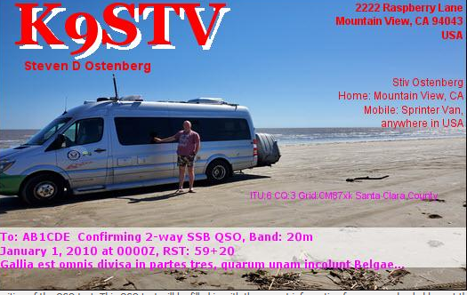
In days of yore, Hams used to send each other postcards to confirm their contacts. Collecting these cards was a hobby for many people. Today, to save on postage and paper, many hams use EQSL. You can use a free account, or pay a small fee to access premium features like custom graphics.
https://eqsl.cc/qslcard/Home5G.cfm

Logbook of the World (LotW)
This site is affiliated with ARRL, and is designed to record and authenticate QSOs (contacts) between Ham Radio operators around the world.
Logbook of The World (arrl.org)

Introduction to Packet Radio
Somewhat stale, updating might be a future project-- Stiv
Introduction to Packet Radio by Larry Kenney, WB9LOZ (choisser.com)

Parks on the Air (POTA)
Register with Parks on the Air to hunt and activate Parks around the world! Collect awards, and use their tools to help you find contacts.
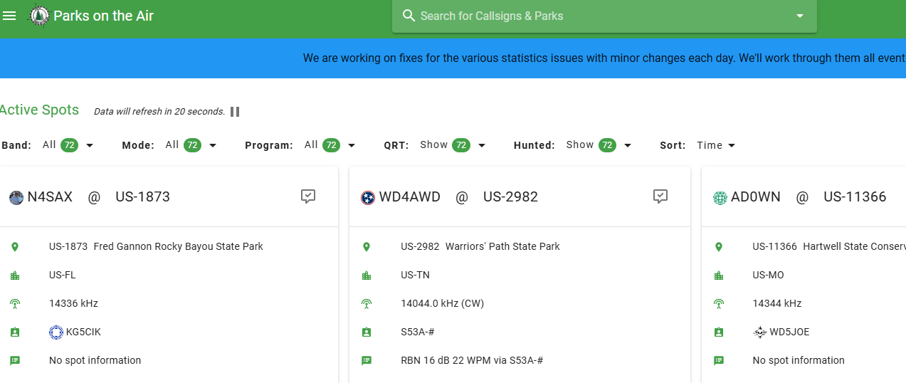
https://pota.app/ - /

QRZ.COM
A callsign lookup database , with Forums, a swapmeet, and other useful information.
Callsign Database - QRZ.com

QRZCQ
The database for radio hams
There is too much stuff here for me to parse. I don’t know enough, but lots of useful utilities
QRZCQ - The database for radio hams

rdf-sf (Fox Hunting in SF Bay)
Radio Direction Finding in the San Francisco Bay Area
Not a club, just some folks who love the hobby holding regular events, but certainly worth knowing about!

rdf-sf.org

Santa Clara County ARES/RACES
The Santa Clara County ARES/RACES site is the hub for EmComm in Santa Clara County. If you wish to participate in EmComm you need to register here. Registration is free, as is training.
An offline copy of the SCCo Website is stored on the MasterHam USB Key. It should be noted that while you can browse the offline copy from the Santa Clara County ARES-RACES Offline file on the root of the MasterHam Key, you can also go through the folders that are in the “www.scc-ares-races.org” folder and find buried in there all the training presentations and forms from the site. Just do a search in the folder for PDF files and see what you get! There is a lot of stuff we don’t need (like 4 versions of each presentation depending on how many slides per page you want) but all the ICS forms and other stuff we do need is there, and I will try to weed out the other stuff in the future.
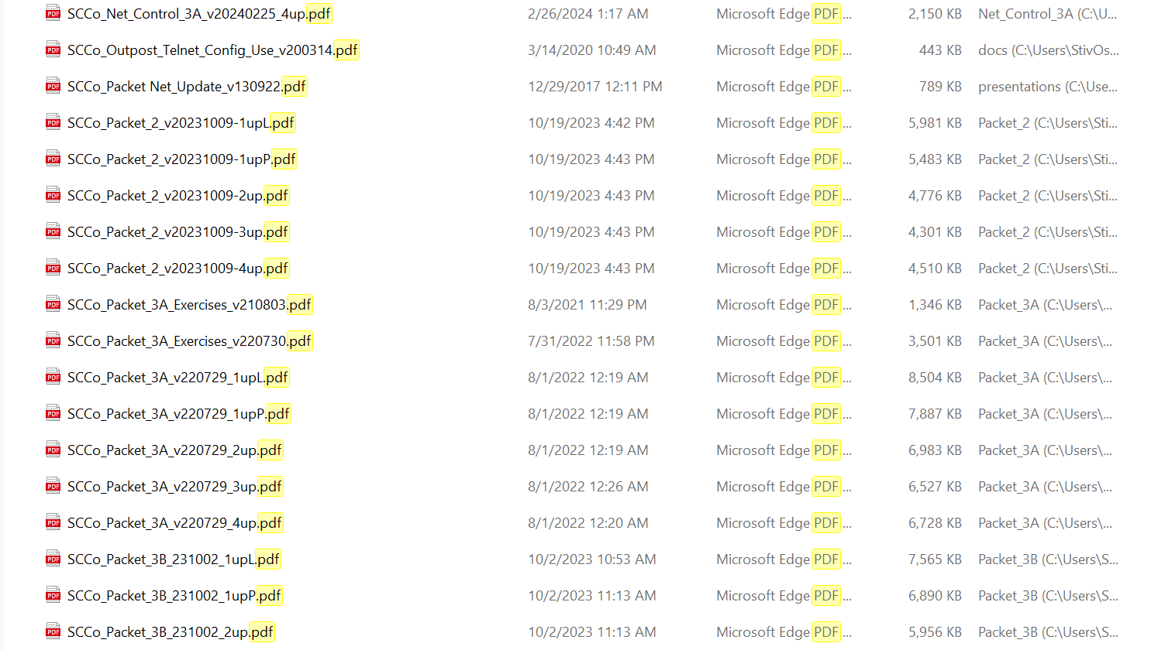

Santa Clara County ARES/RACES (scc-ares-races.org)

Sherwood Engineering
A website that testa and compares radios, good for when you are thinking of buying and need to do some research.
Receiver Test Data (sherweng.com)

Summits on the Air (SOTA)
SOTA is an award scheme for radio amateurs that encourages portable operation in mountainous areas.
New to SOTA?
SOTA has been carefully designed to make participation possible for all Radio Amateurs and Shortwave Listeners - this is not just for mountaineers! There are awards for activators (those who ascend to the summits) and chasers (who either operate from home, a local hilltop or are even Activators on other summits).
SOTA is fully operational in nearly a hundred countries across the world. Each country has its own Association which defines the recognised SOTA summits within that Association. Each summit earns the activators and chasers a score which is related to the height of the summit. Certificates are available for various scores, leading to the prestigious "Mountain Goat" and "Shack Sloth" trophies. An Honour Roll for Activators and Chasers is maintained at the SOTA online database.
SOTA is designed to be compatible with other mountain users. Please see our environmental statement for details.
https://www.sota.org.uk/

Groups.IO Mail Lists
Groups.IO offers two types of subscription for the organization setting it up. A free subscription offers a single group, while a paid subscription offers many subgroups to allow users to selectively pick topics they want to receive mail on. Membership in the main group is required to join subgroups.

Hosting Group | Groups.IO site
A Groups.IO to foster communications throughout the Bay Area. Stiv Ostenberg of SPECS hosting until a sponsor is found. | Announce@SF-Bay-Ham-Radio.groups.io | Home  Announce@SF-Bay-Ham-Radio.groups.io | Subgroups
Amateur Radio Relay League  ARRL hosted topics | ARRL-Groups@groups.arrl.org | Home  ARRL-Groups@groups.arrl.org | Subgroups
BayNet  Bay-Net is an open amateur radio club in the San Francisco Bay Area. | main@baynet.groups.io | Home  main@baynet.groups.io | Subgroups
QSV: Hams who Hack  Meets in Mountain View twice a month. | qsv@groups.io | Topics
South Bay Amateur Radio Association  Fremont | sbarahams@groups.io | Home
Santa Clara County ARES/RACES  The hub for Emergency Communications in Santa Clara County. | announce@scc-ares-races.groups.io | Home  announce@scc-ares-races.groups.io | Subgroups

Software
ADIFMaster
ADIF Master is a highly user-configurable Windows application for working with HAM radio logbooks in ADIF format. ADIF is a generally accepted format for transferring logs between different Logging programs. ADIF Master allows converting any existing Cabrillo, ADX, TR, and CT logs or a part of it into an ADIF file. Also, you can use ADIF Master to open and modify existing ADIF logs using customizable filters, add, remove and modify ADIF tags and entries.
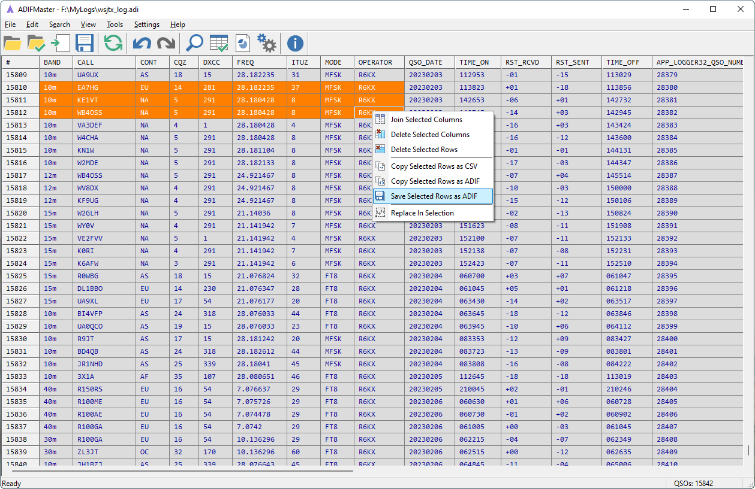
https://www.contestlogchecker.com/adif-master.html

ADIFMerge
An application for merging ADIF files for amateur radio.
Please note, this is a .NET application, so you must have the .NET framework 4.5 from Microsoft installed in order to run it. This framework can be found here: https://www.microsoft.com/net/download/framework.

https://github.com/LCAllen/ADIFMerge/releases

Amateur Contact Log (See N3FJP Loggers for more) (paid, 45 day demo limited contacts)
They also sell a loggers for specific contests, or a package for $60 or so that covers ALL their products.

http://www.n3fjp.com/aclog.html

APRSISCE/32
APRSISCE/32 is an advanced Automatic Packet Reporting System (APRS) Client for Amateur Radio, written for Windows (x86 and x64) and Windows Mobile (CE). It will also run on Linux and Mac OS under WINE, as well as other virtual machines. It does *NOT* run on any Windows CE 5 or 6 GPS unit as of 2012/04/11.
APRSISCE/32 can be configured to run connected directly to the APRS-IS via an internet connection, as well as connected to the APRS-RF network via software modems such as UZ7HO Sound Modem, Dire Wolf or AGWPE, using a TNC, or one of the APRS capable Radios including the Kenwood TH-D72/TM-D710 and Yaesu FTM-350.
For a view of the software in use Julian G4ILO's videos are
http://aprsisce.wikidot.com/downloads

Amateur Contact Log
Amateur Contact Log is a popular logging software, but the company that makes it ALSO sells a pile of contest specific loggers. See N3FJP Loggers
N3FJP's Amateur Radio Software

Chirp
CHIRP is a free, open-source tool for programming your radio. It supports a large number of manufacturers and models, as well as provides a way to interface with multiple data sources and formats.
https://chirpmyradio.com/projects/chirp/wiki/Download - google_vignette

Direwolf
Dire Wolf is a software “soundcard” AX.25 packet modem/TNC and APRS encoder/decoder. It can be used stand-alone to observe APRS traffic, as a tracker, digipeater, APRStt gateway, or Internet Gateway (IGate)
In the early days of Amateur Packet Radio, it was necessary to use an expensive “Terminal Node Controller” (TNC) with specialized hardware. Those days are gone. You can now get better results at lower cost by connecting your radio to the “soundcard” interface of a computer and using software to decode the signals.

https://github.com/wb2osz/direwolf/releases

DMapper
Connects APRS(C) radio GPS tracking technology to higher quality mapping programs, for automatic position plotting/tracking of Search & Rescue, Fire, or other personnel.
http://www.roadfacts.com/software/dmapper/dmapperInfo.htm

Echolink
EchoLink® software allows licensed Amateur Radio stations to communicate with one another over the Internet, using streaming-audio technology. The program allows worldwide connections to be made between stations, or from computer to station, greatly enhancing Amateur Radio's communications capabilities. There are more than 350,000 validated users worldwide — in 159 of the world's 193 nations — with about 6,000 online at any given time.

Stiv Note: Echolink prioritizes radio connections. If a radio has hit the repeater, you will not be able to talk. You may need to be patient to get through. There is a delay, sometimes multiple seconds, before the repeater opens up to you after a transmission.
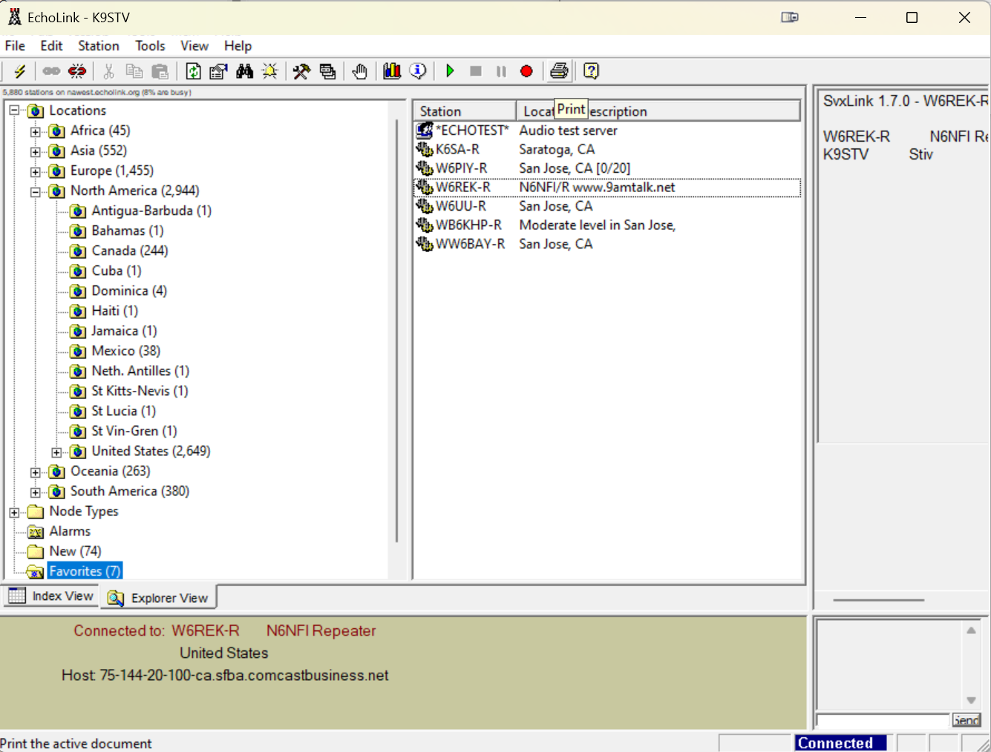
https://echolink.org/download.htm

EQSL Downloader
Small Windows tool to download eQSL's from eQSL.cc .
QSL Cards are downloaded and saved to a local drive as .jpg files.
https://www.oe9ihr.com/download/oe9ihr-eqsl-downloader/

FDLog
K9STV: I have not tried this, it is Python based so multiplatform but it is listed on the ARRL site.

This site is the home for the FDLog Field Day Logging Software. This program interacts with each Field Day station operator and synchronizes the log database across multiple computers via the (usually wireless) network. It cohesively ties the whole Field Day site together and facilitates not only logging but coordinating operations and band occupation. It runs on Windows, Linux and Macintosh using Python.
You can download a copy of the software from the Downloads page here. FDLog is provided free, supported by AntennaLaunchers.com.

https://www.fdlog.us/

Five by Five (Paid) License Prep
The Amateur-only package will prepare you for any or all of the FCC Amateur (aka Ham Radio) tests included in Five by Five. This includes preparation for the Technician, General, and Amateur Extra tests.
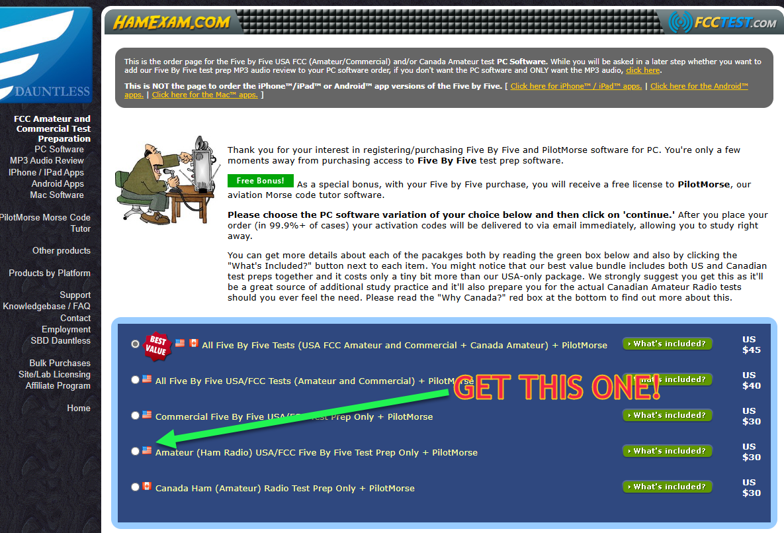
K9STV: This is the software I used to prepare for my General Class license. While the HamCram session would probably suffice, I was paranoid. I liked that this software ran locally, and the price covered all three ham exams and will update as exams change.
https://www.dauntless-soft.com/products/fcctest/fbfpurchase.asp

FLDIGI
Fldigi (short for Fast light digital)^{[4]} is a free and open-source program which allows an ordinary computer's sound card to be used as a simple two-way data modem. The software is mostly used by amateur radio operators who connect the microphone and headphone connections of an amateur radio SSB or FM transceiver to the computer's headphone and microphone connections, respectively.^{[5][6]}
The website also has a ton of other utilities I don’t know yet….
http://www.w1hkj.com/

FreeFileSync
FreeFileSync is a folder comparison and synchronization software that creates and manages backup copies of all your important files. Instead of copying every file every time, FreeFileSync determines the differences between a source and a target folder and transfers only the minimum amount of data needed. FreeFileSync is Open Source software, available for Windows, macOS, and Linux
(StivNote: Will write up how to use this to sync from the MasterHam FTP Server)
Download the Latest Version - FreeFileSync

G4FON Morse Trainer

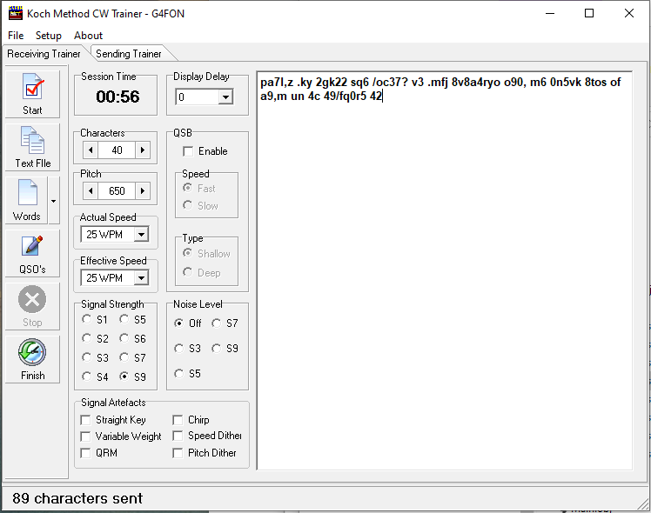
http://g4fon.net/CW Trainer2.php

Gridtracker
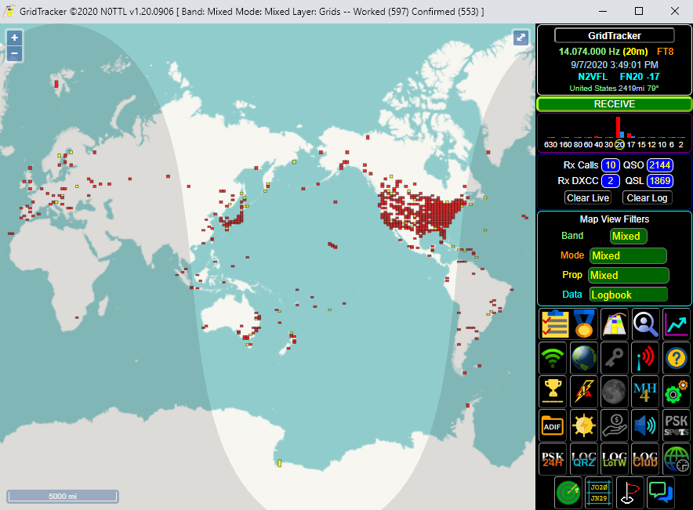
K9STV: This works best alongside WSJT and HRD Logger in my experience
GridTracker is a warehouse of amateur radio information presented in an easy to use interface, from live traffic decodes, logbooks, real-time spot reports, weather, current solar conditions and more!
https://gridtracker.org/index.php/downloads/gridtracker-downloads

Ham Radio Deluxe
A complete suite of software for the amateur radio operator, pretty sophisticated and may be intimidating.
- HRD Rig Control with full command support for Yaesu, ICOM, Kenwood, Elecraft, Ten-Tec, FlexRadio, and more
- HRD Logbook - QSO logging that supports DXing, awards tracking, and digital modes integration with WSJT-X
- HRD DM-780 - Digital Modes support for RTTY, PSK31, and many other digital modes
- HRD Rotator Control for azimuth and azimuth/elevation rotors by Yaesu, HyGain, Green Heron, M2, AlfaSpid, Easycom, Idiom Press, FoxDelta, and more for turning your ham radio antenna
- HRD Satellite Tracking - Satellite communications with rig frequency adjustment for Doppler and az/el tracking of the ham radio antennas
- Perpetual software license (not sold as a subscription)

https://www.hamradiodeluxe.com/downloads/

HamCall
Software that requires registration, offline callsign lookups… Subscription service.
https://hamcall.net/haminfo.html

HamClock
Just a set of instructions I downloaded before I found Gridtracker… Linux based, not Windows…
https://www.thehamshack.blog/hamclock-a-vital-tool-for-amateur-radio-enthusiasts/

HAMRS
Probably the best POTA logging app I have found, I still use it, though it has not been updated to support the new POTA park identifiers.
https://hamrs.app/

JTSync
JTSync is a simple utility that provides the ability to synchronize your computer clock over a network with world-wide NTP servers. When the Internet connection is not available, JTSync allows you to make time adjustments based on decoded QSOs within the WSJT-X application. JTSync supports joining a UDP multicast group when interacting with WSJT-X to run simultaneously with other applications such as JTAlert or GridTracker.
https://www.dxshell.com/jtsync.html

Kantronics
An extra subfolder under “Software” on the MasterHam USB Key. Not exactly software, but this file contains the FTDI USB drivers to allow the Kantronics KPC3+ USB to run on my PC. Keep it for emergencies because the TNC is a brick without the drivers.

Logbook of the World
Logbook of The World (arrl.org)
The software folder on the MasterHam USB Key contains the TQSL program.
TQSL: This is the program used to sign logfiles before uploading to ARRL Logbook of the World. This program REQUIRES that you apply for a certificate you will use to sign your logs to prevent cheating.

MeetUp
This SPECS Meetup group was created to promote events related to Ham Radio and disaster communications in the Bay Area. The events may require registration with the hosting organization, but are usually free. We encourage and support all aspects of Ham Radio, as any operator is a potential EmComm operator.
I highly encourage ham radio operators to join the site, and sign up for events.

Southern Peninsula Emergency Communications System | Meetup

Meinberg NTP
This is another Time Sync software to keep your PC clock synchronized so FT8 will work.
https://www.meinbergglobal.com/english/sw/ntp.htm

MicroLog Logger
Free ham radio logger from WA0H
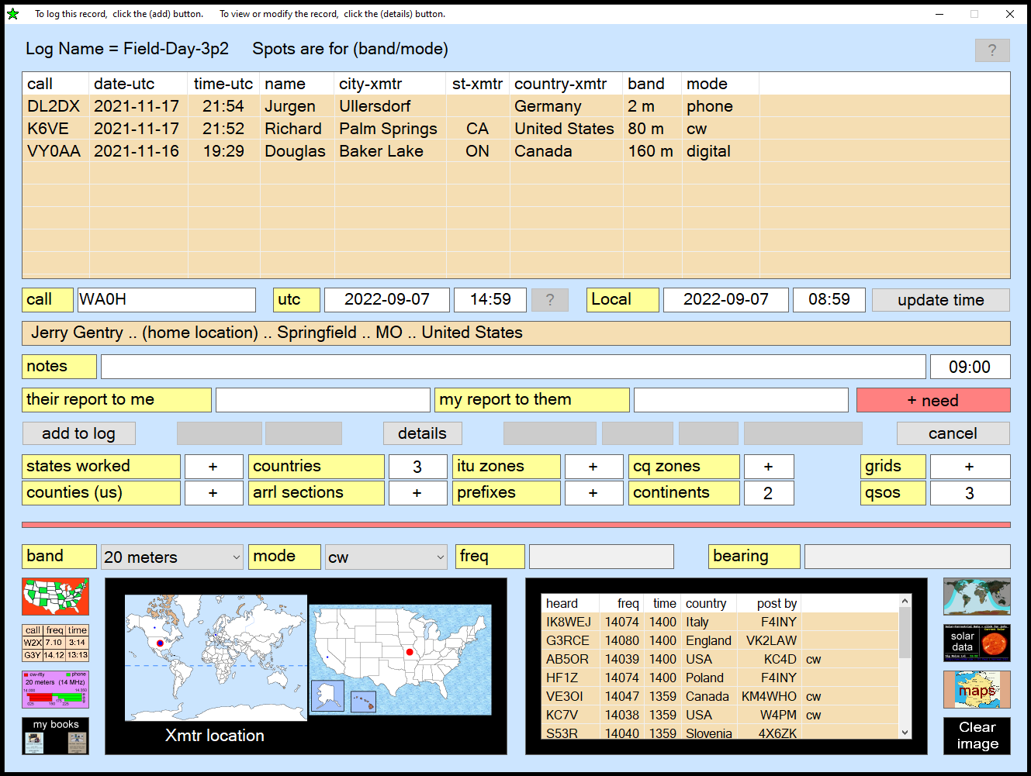
https://wa0h.com/

MSHV
Digital mode software. MSHV Supported working modes: MSK JTMS FSK ISCAT JT6M FT8/4 JT65 PI4 Q65
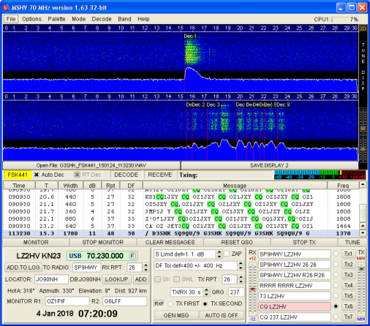

http://lz2hv.org/mshv

NetTime
NetTime is a Simple Network Time Protocol (SNTP) client for Windows 95/98/Me/NT/2000/XP/Vista/7/8/10 and Server 2003/2008/2012/2016. (32 bit and 64 bit operating systems are both supported)
If you're looking for a program to keep your system time accurate, you've just found it!
https://timesynctool.com/

N1MM Logger
N1MM Logger is the world’s most popular ham radio contest logging program. For CW, phone and digital modes, its combination of contest-optimized features is unmatched.
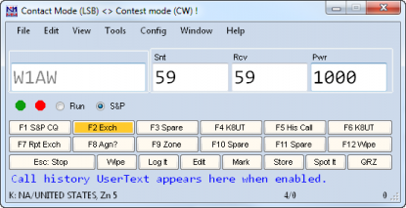

https://n1mmwp.hamdocs.com/

N3FJP Loggers (paid, 45 day demo limited contacts)
Amateur Contact Log is the most popular product:
Very easy and intuitive to use!
Tracking of Worked All States, Worked All Counties, Worked All Countries, DXCC, VUCC, Grids, Zones, IOTAs, Lighthouses and many other achievements.
The user interface is customizable! You can choose to display any of the data fields you want and decide where you want them. The DX Spotting window can now be set to any size you like! You can also change the font sizes of all the fields, lists and text boxes as well!
Includes a database of counties and countries.
Query by band, mode, or power level to easily track your accomplishments by individual and multiple criteria.
Lists previous contact details with the station currently being worked including name, dates of previous contact(s), QTH, etc. just by typing the call in the call field and hitting the Tab key.
http://www.n3fjp.com/aclog.html
https://www.n3fjp.com/fieldday.html
They also sell a large number of loggers for specific contests, or a package for $60 or so that covers ALL their products.

OmniRig (Paid)
This is another suite of Ham Apps, some paid, some free. I have not worked with these yet.
https://www.dxatlas.com/Download.asp

Outpost SCC
Outpost is a Windows-based packet message client that lets you send and receive packet messages with almost any Amateur Radio Bulletin Board System (BBS) or TNC Personal Mail Box
There is a generic version, and there is a bundled version that also comes with PackItForms designed for Emergency Communications operators in Santa Clara County.

Outpost Packet Message Manager | https://www.outpostpm.org/index.php?content=downloads
Santa Clara County Specific Outpost | https://www.scc-ares-races.org/data/packet/client-software.html

PuTTY
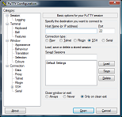
K9STV: Sometimes you need to directly access the Serial port on your pc to talk to a device, such as your TNC. PuTTY allows this.
PuTTY is an SSH and telnet client, developed originally by Simon Tatham for the Windows platform. PuTTY is open source software that is available with source code and is developed and supported by a group of volunteers.
LEGAL WARNING: Use of PuTTY, PSCP, PSFTP and Plink is illegal in countries where encryption is outlawed. We believe it is legal to use PuTTY, PSCP, PSFTP and Plink in England and Wales and in many other countries, but we are not lawyers, and so if in doubt you should seek legal advice before downloading it. You may find useful information at cryptolaw.org, which collects information on cryptography laws in many countries, but we can't vouch for its correctness.

https://putty.org/

RigResident
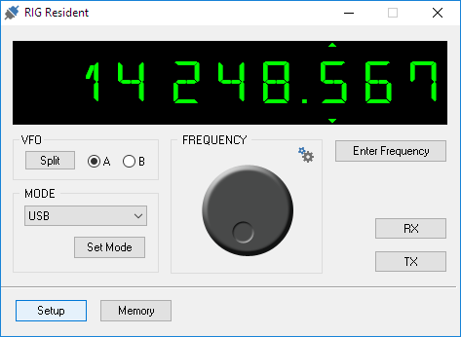
RigResident is a small program that allows you to set and read data (frequency, mode, etc.) of a connected transceiver.
RigResident supports more than 100 TRX models from ICOM, KENWOOD, YAESU, and Ten-Tec:
https://www.dxshell.com/rig-resident.html

SkookumLogger (Macintosh)
SkookumLogger is a contest logging program for macOS 10.15 (Catalina) or later, available on the App Store. The app is self-contained, except that you will need to install drivers for your serial hardware if it uses a type of USB-serial adapter not supported by macOS.
https://apps.apple.com/app/id1539327106

SecureCRT and SecureFx (Paid)
Stivnotes: I used this professionally, and if you are doing work in the cloud it is a must have IMHO. It supports terminal connections to ham radios, but also to just about anything else. SecureFX is useful for synchronization of files from FTP, TFTP and SSH sources. (For instance Elecraft has an FTP server with manuals and all sorts of other stuff to make it easy to download.)

SecureCRT client for Windows, macOS, and Linux combines rock-solid terminal emulation with the strong encryption, broad range of authentication options, and data integrity of the SSH (Secure Shell) protocol for secure network administration and end user access.
SecureFX is a flexible, secure file transfer application with a visual interface that is easy to learn. SecureFX offers advanced features like site synchronization and automation to help web designers and network administrators streamline everyday tasks. Integration with SecureCRT saves time with shared sessions and settings.

Download – VanDyke Software Secure Clients and Servers - VShell SSH Server, SecureCRT SSH client, SecureFX secure file transfer client

TR4W Logger
Free and Open Source
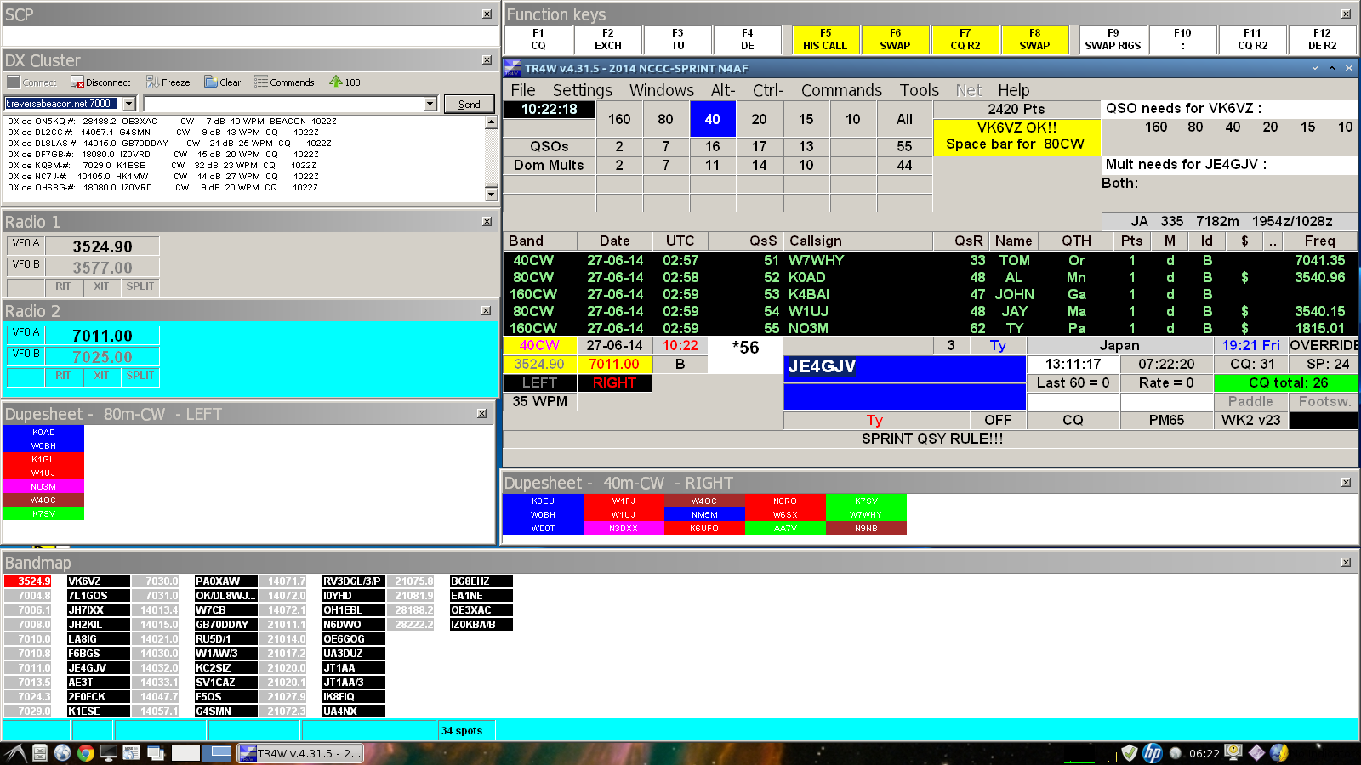https://www.tr4w.net/

https://www.tr4w.net/

VARA (Paid)
K9STV: I have looked into VARA, but not really understood how to use it, yet.

VARA is a type of digital communication mode used in amateur radio. It's a modem protocol specifically designed for high-speed data communication over amateur radio frequencies. VARA stands for "Virtual Audio Radio" and is known for its efficiency in transferring data, particularly in challenging radio conditions.

VARA is capable of high throughput rates, allowing for faster transmission of data compared to some other digital modes in amateur radio. It's often used for activities such as emergency communications, file transfers, and other situations where high-speed data transmission over radio is beneficial. The protocol is designed to perform well even in conditions where the signal might be weak or subject to interference, making it a valuable tool for amateur radio operators.
EA5HVK | Weak signals Software (wordpress.com)

Visual Studio Code
Cross platform text and code editor, understands many programming languages and markup languages.

https://code.visualstudio.com/Download

W3ELPs Tools
A series of programs for helping logging with Ham Radio Deluxe and DM780.
W4ELP@groups.io | Files
As of 9/30/2024:

WinLink
Introducing Winlink Express, the ultimate radio email client designed for seamless communication. With its extensive features and support for the Winlink Hybrid Network, it stands out as the top choice by users. Whether you're operating with or without an internet connection, Winlink Express ensures reliable email delivery.

This user-friendly client is perfect for individuals with a single call sign or those needing to manage multiple addresses simultaneously. It offers compatibility with most transceivers, TNCs, and controllers, supporting a wide range of modes such as ARDOP, VARA HF and FM, Pactor, SCS Robust Packet, VHF/UHF AX.25 packet radio, WiFi, and any TCP/IP RF link. With Winlink Express, you can also connect directly to CMS servers or RMS Relay via internet/telnet, enabling high-speed communication across different networks.

Developed by the Winlink Development Team, Winlink Express prioritizes simplicity while leveraging advanced features. It employs the B2F extension radio transfer protocol, allowing attachments, multiple addresses, and tactical addresses. The client also features peer-to-peer connectivity, enabling direct RF connections to other Winlink Express or Airmail clients.

Winlink Express goes beyond email functionality, offering additional capabilities for emergency communications (EmComm). It supports HTML form creation, compact content transport, and a growing library of up-to-date forms. If you're considering using Winlink Express for EmComm, it's recommended to consult your local EmComm group for guidance and support.
https://winlink.org/WinlinkExpress

WinSCP
WinSCP is a program designed to allow FTP, SFTP, and FTPS file transfers. This program is included to allow file syncs with companies that allow files to be transferred over FTP. WinSCP allows file sync, which means only new or updated files are transferred saving bandwidth.
For example, Elecraft allows users to download drivers and manuals in bulk from their site at ftp.elecraft.com.
If Buddah permits, I will try to make the MasterHam folder available to clubs using this program. (There are many software packages such as Beyond Compare, SecureFX on others that do this, but this program is free.

https://winscp.net/eng/download.php

WriteLog (Paid $30, registration required for demo)
Demo Version
WriteLog for Windows combines the convenience and ease of use of Windows with the performance and features required by the top contest operators. No other package matches WriteLog’s support for CW, Phone and RTTY contesting, and now, in version 12, SDR spectrum display is built into the band map.
Please register your demo
https://writelog.com/downloads/demo

WSJT-X
WSJT-X implements communication protocols or "modes" called FST4, FST4W, FT4, FT8, JT4, JT9, JT65, Q65, MSK144, and WSPR, as well as one called Echo for detecting and measuring your own radio signals reflected from the Moon. These modes were designed for making reliable, confirmed QSOs under extreme weak-signal conditions.
https://wsjt.sourceforge.io/wsjtx.html

WSJT-X Improved
wsjt-x_improved is an enhanced version of the excellent WSJT-X software by Joe Taylor K1JT, Steve Franke K9AN, Bill Somerville G4WJS and others (https://sourceforge.net/projects/wsjt/). Sometimes, however, even good things can be improved …
https://wsjt-x-improved.sourceforge.io/

WSJT-Z
This is a WSJT-X based clone with a modified user interface to the standard WSJT-X interface.
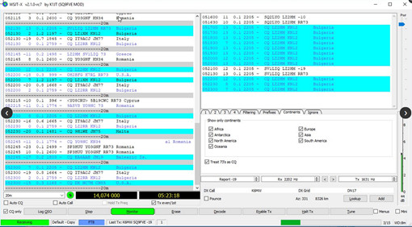
Features
Modified user interface, including a larger Band Activity window
Extended filtering features
Auto CQ and auto responding
Quite nice is that you have all options in a main field at a glance and can minimize this by clicking on “mini” on the main control panel.

But what stands out in particular with this clone is that there is a modification in the operation and now it comes: it is an “auto CQ” possible that means that after executing a QSO’s just continue to call CQ. This can be additionally defined that too every station that is not in its own logbook is called automatically.
Note: This program is controversial because it can automate calling CQ. Some folks call that “cheating”, some don’t care. --Stiv
Download WSJT-Z (sourceforge.net)

Yaesu
A folder under “Software” Just storing drivers for my radios in here.

Where to buy gear

Amazon
Yeah, you know Amazon. You can buy stuff here, but you may end up getting stuck with equipment that is not certified for use in the US. I recommend buying from the Ham Radio Shops listed below. They can answer questions and give advice, and we want them to stay in business.

DX Engineering
At DX Engineering, Amateur Radio is what we know. From the pleasure of rag-chewing to the satisfaction of working that new, rare one—we understand your every need for top-performing and reliable products. It's impossible to overstate the importance of filling those needs.
DX Engineering | Ham Radio Equipment & Supplies

Gigaparts
GigaParts, Inc. is a full service computer and amateur radio store. Our PC department stocks the latest components for upgrading your PC, building your own PC, or having us build one for you. Thanks to our Just-In-Time inventory management system, you will receive the latest technology at competitive prices from GigaParts. Unique relationships with suppliers and shippers allow us to have CPU's, memory, and video cards over-nighted from Silicon Valley every day so price drops are passed on to our customers immediately. Other, less price-volatile, items are purchased in bulk to assure you the lowest possible price.
Our Radio department features the latest products from manufacturers such as Alinco, Icom, Kenwood®, Yaesu, MFJ, Diamond, and many more. Whether you're a DX'er looking for the latest HF rig or a soon-to-be-HAM looking for study materials and a two-meter handie talkie, we have what you need!
GigaParts - Amateur Radio, Computers and More! GigaParts.com

Ham Crazy
This is NOT a store for buying gear, but for buying ham related merchandise like hats, plaques, license plate frames and other items to show off your Ham Pride.
Ham Crazy!, Ham Radio Gifts and Fun Stuff Amateur Radio Operators!

Ham Radio Outlet
HRO is a family owned business with multiple sales locations throughout the United States which include a formidable presence on the Internet, making it the largest Ham Radio dealership in the world.
HRO is continually expanding and one day there may be a location near you!
The nearest shop to drive to if you want to check out the radios and talk to experts before you buy.
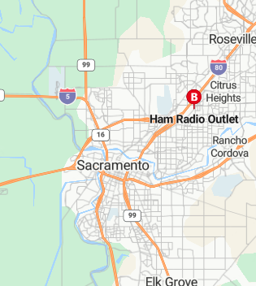
Ham Radio Outlet

Powerwerx
These guys manufacture the Anderson Powerpole connectors, which are the de-facto standard for Emergency communications power. Turns out they also sell some radios, but I would not consider them a full service shop.

Anderson Powerpole, DC Power, Wire & Cable, Two-Way Radios | Powerwerx

R&L Electronics
Ham radio shop
R&L Electronics, Amateur radio store (randl.com)

Cell Phone Applications

Android

Repeater Book
Powered by the popular community database of RepeaterBook.com and
software of ZBM2.com RepeaterBook enables every Ham to easily find repeaters across the the World! - USA, Canada, Mexico and over 70 other countries, for free and without a network connection using the RepeaterBook Directory.
• No network connection required.
• Use GPS, search or network to find Repeaters.
• Displays your grid and selection distance.
• Comprehensive search, selection, sorting and display options.
• Displays distance, heading and full repeater details.
• Fast and flexible, designed to help you use the repeater network.
• Easily submit updates and additions from within the app.
• Supports BlueCAT - FT-857, FT-817, FT897, FT100 and ICOM 7000, 7100, 9100
Bluetooth CAT interfaces
BlueCAT now available worldwide from ML&S - see www.zbm2.com/BlueCAT
Touch a repeater to instantly set your radio, no more fiddling with
CTCSS,frequency and offsets.
RepeaterBook will always be free.

RepeaterBook - Apps on Google Play

Grid Square ($3.99)
Grid Square app displays an 8-symbol Grid Square Locator (a.k.a. Maidenhead Locator, QTH Locator) value calculated based on the geographical coordinates obtained from GPS satellites and mobile network.
Along with your current position, the app will show information about places of interest nearby -
radio beacons, lighthouses, national parks and call signs of the radio amateurs in the area.
In addition, geographical coordinates and altitude information is displayed, together with a compass for orientation. Accuracy - refer exclusively to horizontal dimensions.
Grid Square - Apps on Google Play

EchoLink
Please note: This app is for licensed Amateur Radio operators only. See www.echolink.org for more information.
EchoLink for Android provides access to the EchoLink network from your Android device. You can use this app to connect to the EchoLink system from almost anywhere, using either a WiFi or cellular (3G/4G/LTE) connection.
Access to EchoLink requires a password. If you have never used EchoLink before and you are a licensed Amateur
EchoLink - Apps on Google Play

HAMRS Logger
HAMRS is a simple amateur radio logger, with templates tailored to portable activities like Parks on the Air, Field Day, and more.
You can tab quickly through fields as you make contacts, see operator QTH information with an internet connection, and export your ADI file easily.

HAMRS Logger - Apps on Google Play

Ham Clock
HamClock is targeted for portable amateur radio operators.
It displays time/date and user notes related to various portable locations on a single screen:
- Local date / time
- GMT date / time
- User notes
- Reminder to transmit callsign every 10 minutes, as required in some countries.
Note can be entered in up to four fields. Use it to record location name, QTH locator, callsign, activation details for SOTA, WCA, WFF or other activities, event info etc.
Multiple notes can be entered and saved for later use.
Note view is scrolled to show longer texts
Hide local clock, leaving even more room for notes
- Large font and contrast for readability in bright daylight.
- Light / dark color scheme
- Configurable date format
- Configurable display timeout.
- Optional popup every 10 minutes to remind you to transmit your callsign.
- Optional ringtone played along with the visual reminder. If you don't want audio alert, select "silent" or "none" ringtone.
Ham Clock - Apps on Google Play

IPhone

Windows Phone
Ha ha. Just kidding. Windows Phone is dead.

NETS
((Need to write section on how to connect to repeaters))

Talk Nets
Talk nets are where new hams can find people to talk to. Some repeaters may host multiple Nets. The N6NFI Repeater, for example, has a number of Nets at different times.

9 AM Talk Net (M-F 9am )
The 9 A.M. Talk Net meets on ham radio weekdays at 0900 PT in the San Francisco Bay Area on N6NFI/R
(145.230- MHz, 100Hz PL).
Want to check-in or listen to the net from your office or somewhere out of radio range? Give EchoLink a try on your phone or computer. Connect via W6REK-R or KR6DD-R nodes. You may also listen to N6NFI/R via N6NFI/R on Broadcastify.com.
9 A.M. Talk Net (9amtalk.net)

Bay-Net
Bay-Net is an open amateur radio club in the San Francisco Bay Area. Our repeater system provides wide-area coverage for public service events and emergency communications.
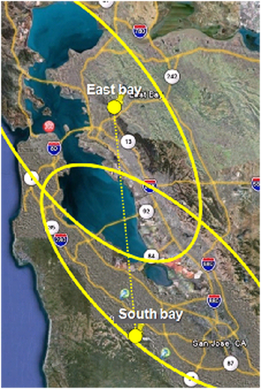
East Bay
443.975 PL 100.0 +5 MHz offset (448.975 input)
The East Bay repeater provides coverage in the San Francisco, Berkeley, Oakland and North Bay areas. This site can be heard as far south as the southern end of the Silicon Valley.
The repeater antenna radiation pattern is designed to point the energy towards the bay and away from the central valley.
South Bay
145.390 PL 100.0 -600 Khz offset (144.790 input)
443.225 PL 100.0 +5 MHz offset (448.225 input)
927.8625 DPL 023, -25 MHz offset (902.8625 input)
​The South Bay repeaters are intended to cover the southern half of the San Francisco bay including Palo Alto, San Jose, Fremont and all of Silicon Valley.

FARS Weekly Net (Thursdays, 8PM)
FARS members meet at 8:00 PM each Thursday evening on the N6NFI repeater, 145.23-. A 100Hz PL is required to access this repeater.
The purpose of the net is to keep FARS members informed about activities; to exchange other amateur radio related information; and to socialize.
This net is open to all interested hams.
After the QSTs have been given, it's time for the rag chew session. During this portion of the net each participant is encouraged to make a contribution. Use this time to relate stories or experiences of interest to hams.
Echolink node(s): W6REK-R (828105) or KR6DD-R (271122).
FARS - Regularly Scheduled Local VHF/UHF Nets (k6ya.org)

PAARA Monday Night Net (Mon 08:30PM)
QST, QST, QST. This is the Palo Alto Amateur Radio Association Net, which meets every Monday evening at 20:30 hours local for the purpose of exchanging information among members of the Palo Alto Amateur Radio Association. on the N6NFI repeater, 145.23-. A 100Hz PL is required to access this repeater.
Echolink node(s): W6REK-R (828105) or KR6DD-R (271122).
PAARA - Nets

SARA Net (Sun 9PM)
Repeater: K6SA, 146,655MHz , - , PL 114.8
K6SA 443.150MHz , + , PL 100Hz
Net – Saratoga Amateur Radio Association (k6sa.net)

SBARA Chat (Mon 7:30pm)
SBARA Chat
Weekly on-the-air talk-net for SBARA members and visitors to chat and exchange ideas
When: Every Monday at 7:30pm - 8pm Pacific Time
Repeater: WA6PWW Repeater, 147.015 MHz, +ve Offset, PL 103.5Hz
SBARA South Bay Amateur Radio Association, KU6S

SBARA Wednesday Night Roundtable (Wed 8PM)
Rag-chew with your buddies on 10 meters, it is great time to relax, everyone's invited !
When: Every Wednesdays at 8:00pm PST/PDT
Frequency: 28.412 MHz
SBARA South Bay Amateur Radio Association, KU6S

San Mateo Radio Club (T,TH, 7PM)
When: Tu, Th 19:00
Where: N6ZX REPEATER 145.370 MHz Minus offset of 600 KHz CTCSS (PL): 107.2 Hz

There is a roll-call of members and afterwards guests are invited to check-in. Announcements are made about club activities and items of local radio interest before the NET is closed.

Youth Net (Tuesday, 7PM)
This net is for all young hams who are 18 and younger. If you have a son or daughter who is a ham, please let them know about this net. If they are not a ham, encourage them to listen to the net and get their ticket. Ham over the age of 18 can participate in the later portion of the net and can answer questions to help mentor the young hams. There is something for everyone! Please join us!
When: Every Tuesday evening at 19:00 (Pacific) local time
Repeater: N6NFI Repeater, 145.230- MHz, PL 100 Hz.
Net Controllers: Joshua KM6JUP, and Alexia KM6LGG
Echolink node(s): W6REK-R (828105) or KR6DD-R (271122).
Please send an email to sbarayouthnet@gmail.com, if you have any questions, suggestions, etc. NO SPAM PLEASE!

EmComm Nets
EmComm Nets allow hams to check in to test their own equipment, make sure the infrastructure is working, and allow operators to practice managing and participating in a new. It may sound boring, but it is good practice to listen and record callsigns to hone your skills.
(Check here to see the latest)

City Nets
Net | Day | Time | Frequency
Campbell | Tuesday | 1945 | 146.565 MHz
Cupertino | Tuesday | 1945 | 147.570 MHz  440.150 MHz (+) 100.0 Hz (W6TDM)
Loma Prieta | Tuesday | 1915 | 440.550 MHz (+) 94.8 Hz (AB6VU)  146.835 MHz (-) 94.8 Hz (AE6KE)
Los Altos | Monday | 2010 | 146.595 MHz
Los Gatos /  Monte Sereno | Sunday | 2030 | 147.390 MHz (+) 151.4 Hz (W6PIY)*  444.700 MHz (+) 127.3 Hz (WB6KHP)**
 | Monday | 2000
 | Tuesday | 1930
Milpitas | Tuesday (except last) | 1915 | 145.430 MHz (-) 85.4 Hz (W6MLP)  224.700 MHz (-) 100.0 Hz (W6MLP)
 | Last Tue. of the month | 1915 | 147.525 MHz
Mountain View | Monday | 2010 | 146.535 MHz
San Jose | Tuesday | 1920 | 146.475 MHz, 100.0 Hz
 |  | 1940 | 146.985 MHz (-) 114.8 Hz (W6UU)
Santa Clara | Tuesday | 1930 | 147.510 MHz, 100.0 Hz  442.025 MHz (+) 100.0 Hz (K6SNC)
Saratoga | Sunday | 2100 | 146.655 MHz (-) 114.8 Hz (K6SA)  443.150 MHz (+) 100.0 Hz
South County  (Morgan Hill, Gilroy) | Tuesday | 1930 | 147.825 MHz (-) 100.0 Hz (W6GGF)
Sunnyvale | Monday | 1930 | Rotates

Group Nets
Net | Day | Time | Frequency | Notes and Contact Info
SPECS Net | Monday | 1930 | 224.140 MHz (-) 88.5 Hz (W6ASH)  440.800 MHz (+) 100.0 Hz (W6ASH) | Net details  Net control responsibility rotates.  Make on-air contact during or after the net.
 |  | 2000 | 145.270 MHz (-) 100.0 Hz (W6ASH)
SVECS Net | Tuesday | 2000 | 146.115 MHz (+) 100.0 Hz (AA6BT)  444.625 MHz (+) 110.9 Hz (N6NAC) | Net details  Net control responsibility rotates.  Make on-air contact during or after the net.
Weekly Packet Practice | Monday & Tuesday | < 1900 | Packet Frequencies | Messages must be received by 1900 hours.
HF Net | Tuesday (except 3rd Tuesday) | 2030 | 3.878 MHz (LSB) | Darryl Presley, KI6LDM
County Training Net | 3rd Tuesday of 1st month each quarter. | 2030 | 440.800 MHz (+) 100.0 Hz (W6ASH)  146.115 MHz (+) 100.0 Hz (AA6BT)  444.625 MHz (+) 110.9 Hz (N6NAC) | See schedule and info here  Judy Halchin, KK6EWQ, Training Manager
Hospital Net | 4th Wed. of the month (excluding Nov. & Dec.) | 1900 | 145.230 MHz (-) 100.0 Hz (N6NFI) | See SCCo ARES/RACES Leadership
SPECS Net Member cities/orgs: Los Altos, Los Altos Hills, Mountain View, NASA/Ames, Palo Alto, Stanford University, Sunnyvale
SVECS Net Member cities: NASA/Ames, Campbell, Cupertino, Gilroy, Loma Prieta, Los Gatos/Monte Sereno, Milpitas, Morgan Hill, San Jose, Santa Clara, Saratoga,

Other Communication Channels
While Hams are all about radio, we often use other channels to communication. Some services require an invite, some do not. Slack and Discord are both applications, while Groups.IO is a website that lets you subscribe to E-Mail lists. I am adding to this list as I find what tools local clubs are using.

Discord
Discord was primarily a gaming app, but has become so powerful that many groups rely on it to handle their communications.
(PAARA has an unofficial Discord Server for members)
Download Discord to Talk, Chat, and Hang Out

Groups.IO
Groups.IO allow users to sign up with a mail list on various topics to talk via email. Usually you sign into one account, then you have access to all subgroups there. When you subscribe to a group, you receive and can respond to messages in your Email.

ARRL
The ARRL has a groups.io site, with a subgroup for new hams.
ARRL-Groups@groups.arrl.org | Home

SF Bay Area Ham Radio (Stiv’s list)
This is my attempt to create a global list in our area, to facilitate communications beyond just clubs.
Announce@SF-Bay-Ham-Radio.groups.io | Home

Santa Clara County ARES/RACES
The site for Emergency Communications in Santa Clara County.
announce@scc-ares-races.groups.io | Home

SBARA
The SBARA Club list.
sbarahams@groups.io | Home

Slack
Similar to Discord, but targeted at corporate collaboration, Slack is also used by some clubs to manage communications.

Windows | Downloads | Slack

Mac | Downloads | Slack

